ACTIVITY DESCRIPTION | STEP | INSPECTION FUNCTION | APPLICABLE STANDARD | ACCEPTANCE CRITERIA | SWMS |  | VAST INSPECTION | SIGNATURE |  | DATE | RECORDS/ REMARKS RESULTS
REFER TO DRAWING TO DETERMINE CABLE SUPPORT ROUTE AND CHECK SEPARATION FROM DATA/COMMS SERVICES | 1 | CO-ORDINATE WITH OTHER SERVICES | DRAWINGS & REGULATIONS  REFER ATTACHED | COMPLIES
DETERMINE CABLE SIZE AS PER ITP 30 SELECTION OF CABLES FOR SUBCIRCUIT WIRING ETC. | 2 | CALCULATION | AS/ANZ  3000:2007, AS/ANZ  3008:1998 | COMPLIES
CABLE SIZES MAX LENGTH  ____________ ____________  ____________ ____________  ____________ ____________ | 3 | VISUAL | AS/ANZ  3000:2007, AS/ANZ  3008:1998
DETERMINE CABLE SUPPORT SYSTEM ie. CATINARY, CABLE TRAY, FIX TO STRUCTURE, DUCTING | 4 | VISUAL | AS/ANZ  3000:2007 SPEC. | COMPLIES
INSTALL CABLE SUPPORT SYSTEM | 5 | SELECT APPROPRIATE FIXINGS | MAX CENTRES  CABLE TRAY  2 METRES  CATINARY  20 METRES  (Support to prevent sagging if necessary.) | COMPLIES
ACTIVITY DESCRIPTION | STEP | INSPECTION FUNCTION | APPLICABLE STANDARD | ACCEPTANCE CRITERIA | SWMS |  | VAST INSPECTION | SIGNATURE |  | DATE | RECORDS/ REMARKS RESULTS
ALL CABLES ARE TO BE IDENTIFIED AS FOLLOWS: DB NO. FOLLOWED BY CIRCUIT NO. THEN FEED OR ACTIVE, WHITE CABLE MARK WITH BLACK TEXTA, BLACK CABLE WHITE TAPE THEN MARK WITH BLACK TEXTA. WHEN ROUGHING IN POWER CIRCUITS IN STUD WALL ETC. THE LOOP IN LOOP OUT AT THE GPO LOCATION SHALL BE TAPED TOGETHER. IF THE CABLES ARE TAPED
TOGETHER IT WILL ENSURE THAT THE TRADESMEN FITTING OFF THE GPO WILL CONNECT ALL CABLES. AS TRADESMEN COMPLETE THE ROUGH IN THEY SHOULD MARK UP THE DRAWINGS THE LOCATIONS OF THE FEEDS AND RUNS ETC. THIS WILL ASSIST WHERE ANOTHER TRADESMAN COMPLETES THE JOB AND FIT OFF.

CHECK CABLE SIZE/TYPE, BLACK SHEATH FOR POWER, WHITE SHEATH FOR LIGHT: 4MM TO BE USED FOR RUNS OVER 90 METRES (UNLESS SPECIFIED DIFFERENTLY) | 6 | CHECK SIZE TYPE & COLOUR | AS 3008,  AS/NZS 3000:2007AS SPECIFIED | COMPLIES
INSTALL AND IDENTIFY CABLES. ANY CABLE NOT TERMINATED IMMEDIATELY MUST HAVE THE ENDS TAPED COVERING THE BARE COPPER. | 7 | VISUAL | AS DETAILED & TAPED ENDS | COMPLIES
FIX CABLES TO SUPPORT SYSTEM | 8 | VISUAL | AS/NZS  3000:2007 / SPEC. | MAX. 900 CENTRES
FIT-OFF OUTLETS, PLUG BASES ETC. (IF NECESSARY), EACH CIRCUIT TO BE FITTED OFF COMPLETELY & CLEAN UP AREA | 9 | CHECK CONNECTIONS, ALL OUTLETS ON CIRCUIT FITTED/ MADE SAFE. | AS/NZS  3000:2007. | COMPLIES

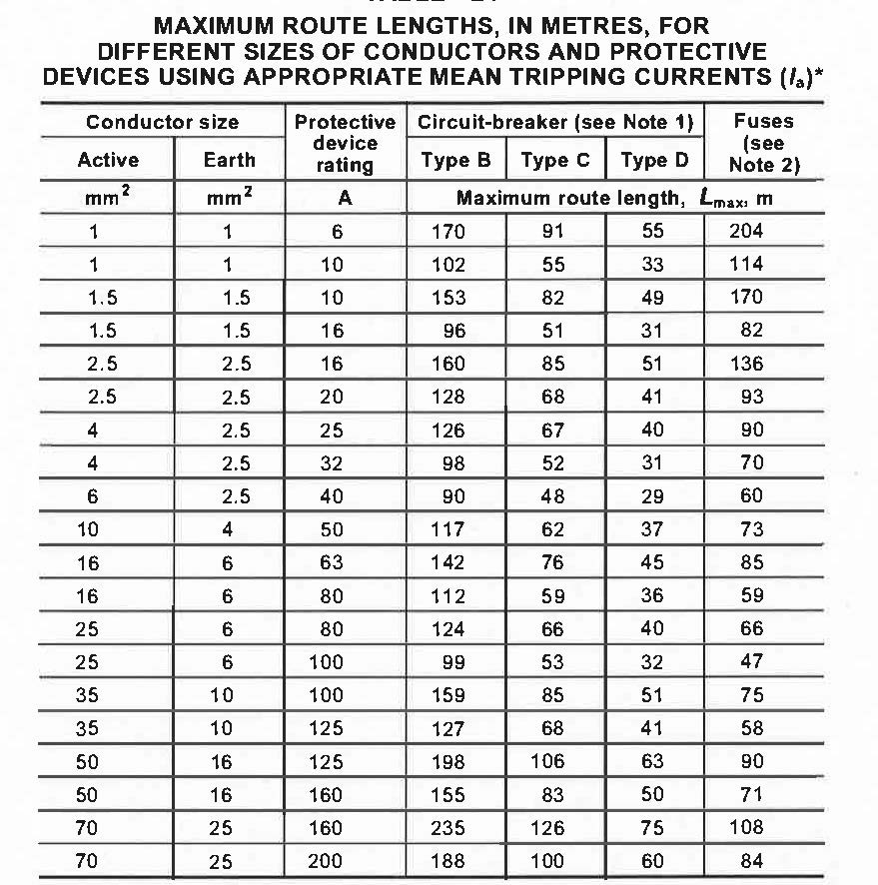
Final Sub Circuit Wiring

SEPERATION BETWEEN POWER AND TELECOMMUNICATIONS CABLES

Circuit Rating | Separation Distance, mm
Low Voltage  High Voltage Multicore  High Voltage Single core | 300  450  600

